**Experiment 2: Internal CSS**

**Aim:** To make View Pages for project.

**Tags Used:**

<style>

. -> is used for id

# ->is used for class

Background-color

Padding

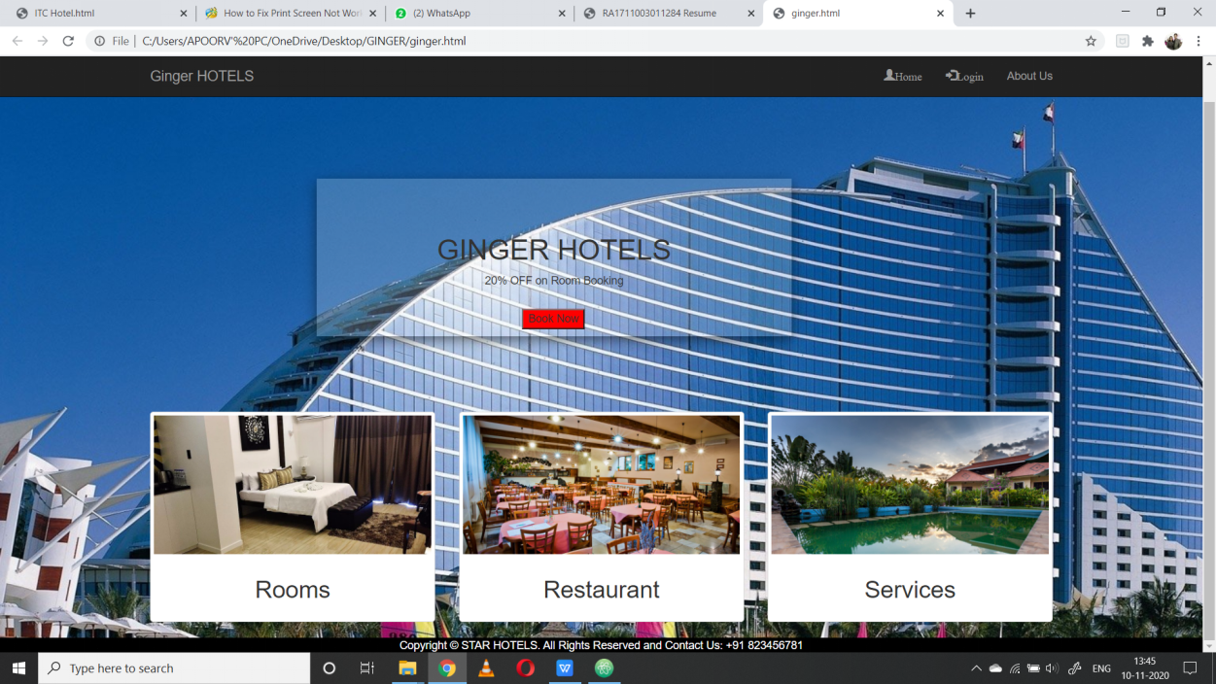Margin-left

**Implementation:**

**Output:**

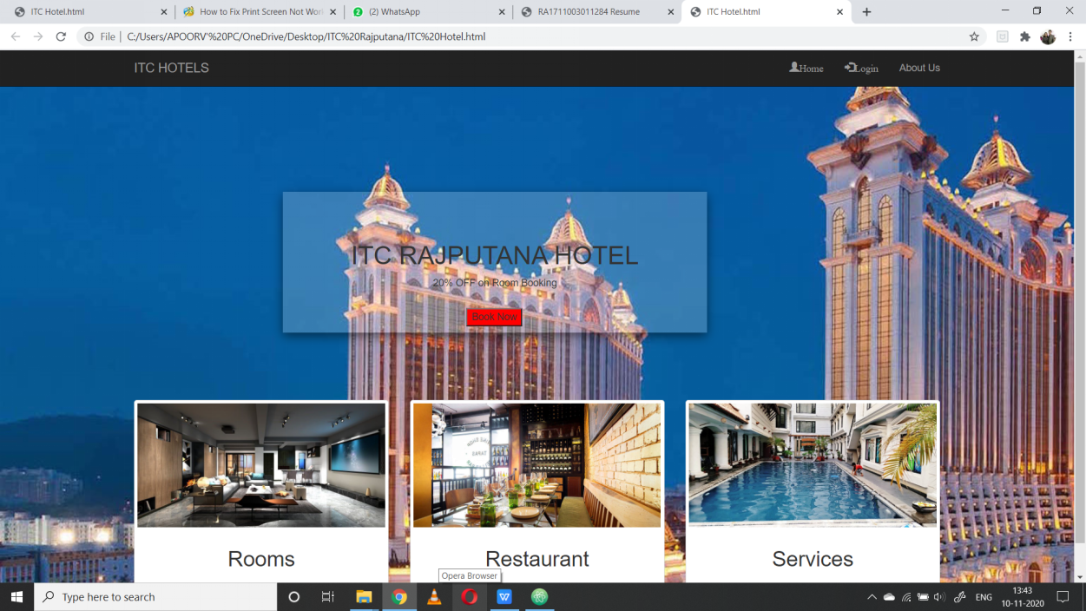

**Code:-**

**<!DOCTYPE html>**

**<html>**

**<head>**

**<link rel="stylesheet" href="https://maxcdn.bootstrapcdn.com/bootstrap/3.3.7/css/bootstrap.min.css">**

**<script src="https://ajax.googleapis.com/ajax/libs/jquery/1.12.4/jquery.min.js"></script>**

**<script src="https://maxcdn.bootstrapcdn.com/bootstrap/3.3.7/js/bootstrap.min.js"></script>**

**<title></title>**

**<link href="style.css" rel="stylesheet">**

**</head>**

**<body>**

**<header>**

**<nav class="navbar navbar-inverse navbar-fixed-top">**

**<div class="container">**

**<div class="navbar-header">**

**<button type="button" class="navbar-toggle" data-toggle="collapse" data-target="#mynavbar">**

**<span class="icon-bar"></span>**

**<span class="icon-bar"></span>**

**<span class="icon-bar"></span>**

**</button>**

**<a href="index.html" class="navbar-brand">ITC HOTELS</a>**

**</div>**

**<div class="collapse navbar-collapse" id="mynavbar">**

**<ul class="nav navbar-nav navbar-right">**

**<li><a href="sign.html"><span class="glyphicon glyphicon-user">Home</span></a></li>**

**<li><a href="login.html"><span class="glyphicon glyphicon-log-in">Login</span></a></li>**

**<li><a href="login.html">About Us</span></a></li>**

**</ul>**

**</div>**

**</div>**

**</nav>**

**</header>**

**<main>**

**<style>**

**body {**

**background-image: url("holidayinn.jpg");**

**background-position: relative;**

**background-color: #cccccc;**

**}**

**</style>**

**<section>**

**<style>**

**.transbox{**

**margin-top: 200px;**

**margin-left: 400px;**

**margin-bottom: -105px;**

**position:center;**

**max-width:600px;**

**padding:50px;**

**opacity:0.3px;**

**background:rgba(255, 255, 255, 0.2);**

**box-shadow:0 5px 15px rgba(0, 0, 0, 0.5);**

**}**

**</style>**

**<div class = "transbox">**

**<style>**

**<style>**

**.button {**

**border: none;**

**color: white;**

**padding: 15px 32px;**

**text-align: center;**

**text-decoration: none;**

**display: inline-block;**

**font-size: 16px;**

**margin: 4px 2px;**

**cursor: pointer;**

**}**

**.button1 {**

**background-color: red;**

**margin: 0;**

**position: absolute;**

**top: 50%;**

**left: 46%;**

**-ms-transform: translate(-50%, -50%);**

**transform: translate(-50%, -50%);**

**}**

**</style>**

**<h1 style = "text-align:center;">ITC RAJPUTANA HOTEL</h1>**

**<p style="text-align:center;">20% OFF on Room Booking </p>**

**<button class="button button1">Book Now</button>**

**</section>**

**<section>**

**<div class="container">**

**<div class="padding-20"></div>**

**<div class="row" style = "padding-top:200px;">**

**<div class="col-xs-4 text-center">**

**<div class="thumbnail">**

**<a href="products.html"><img src="itcroom.jpg"width = "500"></a>**

**<div class="caption">**

**<h2>Rooms</h2>**

**</div>**

**</div>**

**</div>**

**<div class="col-xs-4 text-center">**

**<div class="thumbnail">**

**<a href="products.html"><img src="itcrest.jpg" width = "500"></a>**

**<div class="caption">**

**<h2>Restaurant</h2>**

**</div>**

**</div>**

**</div>**

**<div class="col-xs-4 text-center">**

**<div class="thumbnail">**

**<a href="products.html"><img src="itcswim.jpg" width = "500" ></a>**

**<div class="caption">**

**<h2>Services</h2>**

**</div>**

**</div>**

**</div>**

**</div>**

**<div class="padding-20"></div>**

**</div>**

**</section>**

**</main>**

**<style>**

**.footer {**

**position: relative;**

**left: 0;**

**bottom: 0;**

**width: 100%;**

**background-color: black;**

**color: white;**

**text-align: center;**

**}**

**</style>**

**<footer>**

**<div class="footer">**

**<center>**

**Copyright © STAR HOTELS. All Rights Reserved and Contact Us: +91 823456781**

**</center>**

**</div>**

**</footer>**

**</body>**

**</html>**

**Result:**The experiment was successfully completed.